5 Cell Isolation Techniques to Consider for Cancer Research

Posted by Luke Doiron on Aug 4, 2015 8:00:00 AM

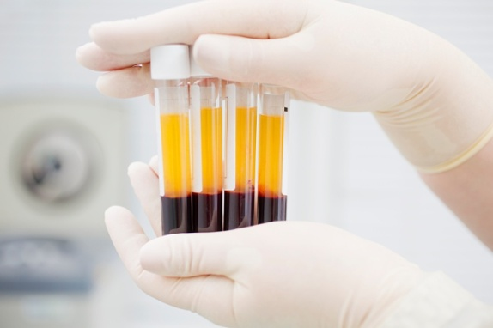
Cells from patients suffering from cancer are invaluable research tools for drug discovery, cancer stem cell studies, immunotherapy protocols, and research into understanding the pathways of cancer metastasis. It’s become widely accepted that because tumors contain a large variety of heterogeneous cell populations, isolating and studying those cells is key to advancing cancer research. There are a number of methods that are traditionally used to isolate different cell types from a mixed suspension. As well, there are new and innovative techniques being investigated to determine their utility in cancer research programs. Consider these five cell isolation techniques:

Fluorescent-activated cell sorter
An antibody is coupled to a fluorescent dye to label specific cells. These labeled cells are then separated from their unlabeled counterparts in an instrument known as a fluorescence-activated cell sorter. This device works by sending individual cells in a single file traveling in a thin stream through a laser beam; the fluorescence of each cell is then quickly measured. Tiny droplets are generated by a vibrating nozzle, and most will contain one cell or no cells. Those droplets with a single cell are given a positive or negative charge, depending on whether they are fluorescent; these cells can then be deflected using an electric field into a container. This instrument is able to accurately select a mere one fluorescent cell from a pool of 1000 unlabeled cells and sort several thousand cells per second.

Laser microdissection
Cells of interest can be carefully dissected from thin tissue slices prepared for microscopy. In this method, the tissue section is coated with a thin plastic film and an area containing the selected cells is irradiated with a focused infrared laser beam pulse. This melts a small circle in the plastic film, causing cell binding underneath. Those captured cells are removed for additional analysis. This technique is good for separating and analyzing cells from different parts of a tumor, which allows for a comparison of their similar and distinct properties. It wasused recently to analyze pituitary cells from dissociated tissues and from cultured populations of heterogeneous pituitary, thyroid, and carcinoid tumor cells, as well as analyzing single cells found in various sarcomas.

Fluorescent nanodiamonds
In this recently published article, authors used fluorescent nanodiamonds (FNDs) to label and isolate slow-proliferating/quiescent cancer stem cells, which, according to study authors, have been difficult to isolate and track over extended time periods using traditional fluorescent markers. It was concluded that nanoparticles do not cause DNA damage or impair cell growth, and that they outperformed EdU and CFSE fluorescent labels in terms of long-term tracking capability.

Magnetic beads
Probably the most commonly used method for cell isolation and separation, magnetic beads are spherical polymer particles with a uniform size and a consistent, defined surface for the adhesion or coupling of a wide variety of cells, including cancer cells. One of the most common uses of this technology is for isolating circulating tumor cells (CTCs) from the blood of breast, NSC lung cancer, prostate and colon cancer patients using an antibody against EpCAM, a cell surface glycoprotein that has been found to be highly expressed in epithelial cancers. EpCAM is thought to act as either a tumor promoter or suppressor in cancer.

Microfluidics
One of the newest technologies, this method used a microfluidic chip with a spiral channel that can isolate circulating tumor cells (CTCs) from blood based upon their size. A sample of blood is pumped into the device and as cells flow through the channel at high speeds, the inertial and centrifugal forces cause smaller cells to flow along the outer wall while larger cells, including CTCs, flow along the inner wall. Researchers have used this chip technology to isolate CTCs from the blood of patients with metastatic lung or breast cancer.

